NC State University
Department of Electrical and Computer Engineering
ECE 575: Spring 2012
Project: Multihop Internet

by
Arun Sriraman
Rahul Khandelwal
Shyam Prasad
Venkatesh Shenoy

Introduction:
Modern operating systems combine features of computer operating systems with other features such as touchscreen, bluetooth, WiFi, GPS, PDA etc. In current market, as many as 55% of these smartphones are using Android Operating systemsTM. Being an open operating systems, Android provides us an opportunity to develop applications to suit the requirements. One such application we have developed here is Multihop Internet. The idea behind this application is to make use of existing infrastructure to provide internet connectivity to handheld devices in adhoc manner. Android devices have multiple RF interfaces such as Bluetooth, WiFi and UMTS. With a custom Android application we can start services and switch between these interfaces such that w always have internet connectivity.
Problem Formulation:
First we try to identify the network model for the situation. The approach here is to establish peer-to-peer communication in ad-hoc manner. So we start with bluetooth adhoc network and with certain shell commands we can ping between the two devices. In next stage we introduce capabilities such as NAT and forwarding on gateway device. With this accomplishment itis clear that we can connect single device. Now we try to extend the same to multiple client devices.
Device Setup:
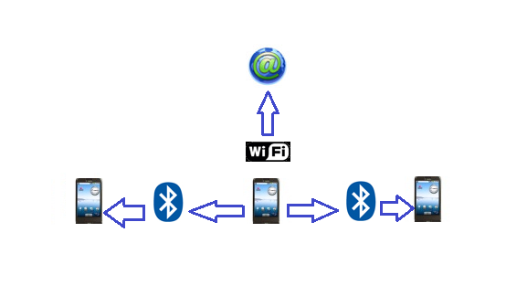
In this part of the application we provide connectivity to multiple users in absence of internet connectivity through WLAN interface with the help of an Android Application. Users start the application when they detect no internet connectivity. The user interface of the application has two simple radio buttons, server and client. The distinction between the state is to differentiate services offered by each.
A server will have both Radio interfaces up and it will compulsorily have internet connectivity. It is imperative that server will act as gateway and DNS server. It does actively listen for incoming requests from client devices. User will be probed to pair the client device and upon successful pairing chain of commands get executed on both server and client. Server will assign an IP address to the BNEP (Bluetooth Network Encapsulation Protocol) interface which is created after successful pairing. Also server installs a NAT table entry, it also installs IP routing table rule to forward traffic matching the criteria. Similarly, on client we issues commands which install IP address on the interface, entries related to DNS server and default gateway. To execute any of these commands, we should be in superuser mode. Android Debug shell prompt is terminal emulator for Android devices and we are automating few shell commands through the application.
Important Commands:
The commands we automate which help us establish multihop internet are as follows
On server, we start with commands,
proc = runtime.exec("su");
To listen for incoming requests we enter the command

pand --listen --role NAP

While any output of netcfg results in bnep interface we execute following set of commands

ifconfig bnep0 x.x.x.x netmask 255.255.255.0 up
iptables -t nat -A POSTROUTING -o tiwlan0 -j MASQUERADE"
iptables -A FORWARD -i bnep0 -j ACCEPT
echo 1 > /proc/sys/net/ipv4/ip_forward

Similarly on client device, the chain of commands are as follows

pand --connect xx:xx:xx:xx:xx:xx
ifconfig bnep0 x.x.x.y netmask 255.255.255.0 up
route add default gw 10.0.1.1 dev bnep0
setprop net.dns1 x.x.x.y
echo 1 > /proc/sys/net/ipv4/ip_forward

Results:

In this milestone, we have single server and multiple devices intending to join as clients. With these commands we can have multihop internet on the client devices. Multiple hops to internet can be clarified with a traceroute ouput and internet connectivity can be verified with ping command or browser traffic. The screen shots for these are as follows.

The graphic user interface of the application is simple as follows

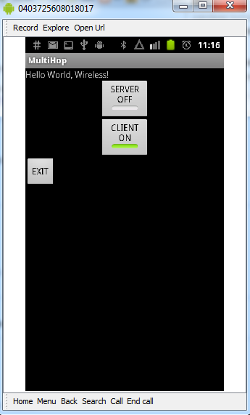
User has option to enable his device as a server. Similarly, in absence of internet we can switch from server mode to client mode. When client can successfully connect to gateway device, it can not just ping but can perform traceroute also. Here is a snippet for the same.

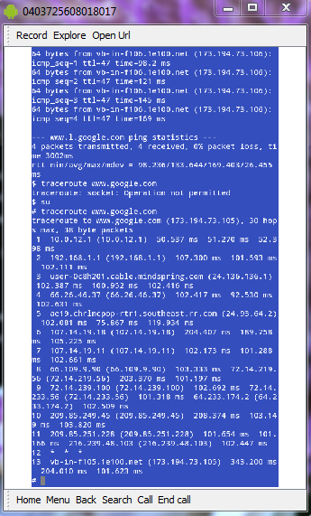
and ping results are as follows

